Project Initialization and Planning Phase

Date | 1 Dec 2025
Team ID | RT
Project Name | Restaurant Recommendation System
Maximum Marks | 3 Marks

Problem Statements (Customer Problem Statement):

I am a busy foodie professional in Bangalore who loves exploring new cuisines. I'm trying to find restaurants matching my taste preferences and location quickly. But I get overwhelmed by endless generic app suggestions and irrelevant reviews. Because platforms prioritize popular spots over my specific cravings like 'spicy vegetarian pizza' Which makes me feel frustrated and waste time on bad meals.
I am a family parent with picky kids in Bangalore, constantly juggling work, and family meals. I'm trying to discover family-friendly eateries nearby that have kid-approved menus within our budget. But I must sift through endless adult-focused reviews, unreliable ratings, and listings that ignore our specific taste and child-friendly vibes. Because current platforms lack proper group filtering, location precision, and family-specific recommendations based on collective preferences. Which makes me feel stressed, exhausted, and defeated after another failed dinner outing.

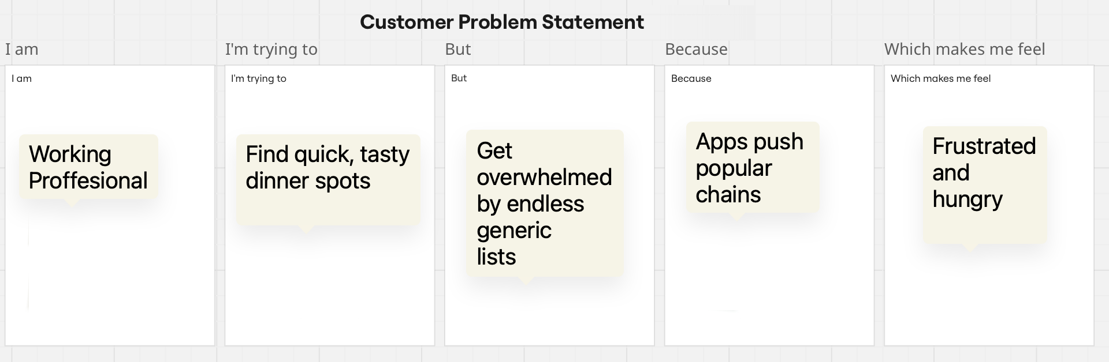
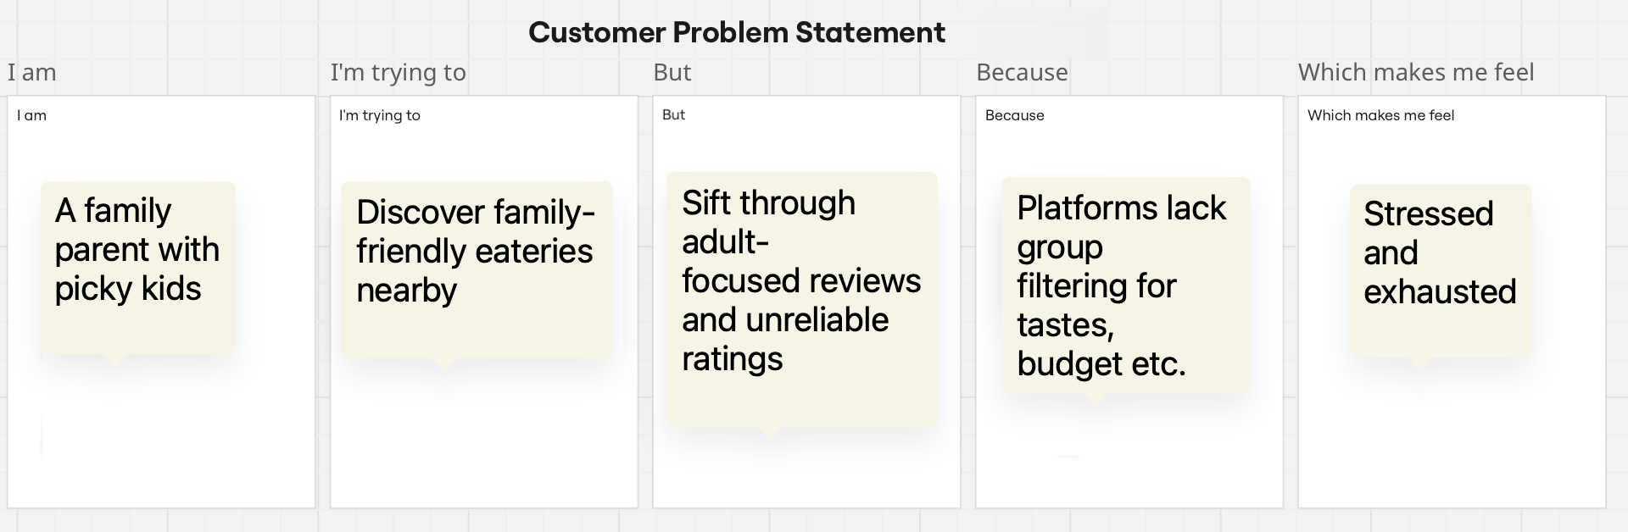

Problem  Statement (PS) | I am  (Customer) | I’m trying to | But | Because | Which makes me feel
PS-1 | A busy  working  professional | Find quick, tasty  dinner spots  matching my spicy  vegetarian cravings | Get overwhelmed  by endless generic  lists and irrelevant  ads | Apps push popular  chains ignoring my  past reviews and  exact location | Frustrated  and  hungry
PS-2 | A family  parent with  picky kids | Discover family-  friendly eateries  nearby with kid-  approved menus | Sift through adult-  focused reviews  and unreliable  ratings | Platforms lack group  filtering for tastes,  budget, and child  vibes. | Stressed  and  exhausted

